What are the most effective designs for multiple sensorial media when creating and sustaining experiences of expressive play?

Computer vision for gesture recognition, touch surfaces (like the Apple's iPhone, Microsoft's Surface and TUIO systems), wireless control devices, accelerometers and game control devices, like data gloves, can be used beyond their originally designed purpose. Increasingly these technologies and the means to programme them are finding their way into the hands of non-specialists and are crossing boundaries of practice. The present chapter works in an interdisciplinary way between human-computer interaction/interface design, computer programming and the performance practice of puppetry, evaluating the reciprocal opportunity for innovative multi-modal practice.

The established puppetry traditions, as categorised by control mechanisms and form: rods, shadows and glove, (one may add the direct manipulation of objects and the related area of toys and automata), have fascinating parallels with moving objects in the virtual worlds of interactive art and games. The chapter will clearly establish and test the boundaries of these parallel forms.

An emerging methodological approach called media archeology, will be used to trace how traditional puppetry forms, often described by their mode of interaction/media, (rods, shadows, strings and gloves) - map into the emerging paradigm of multiple sensory interaction and multi-modal practice.

Puppetry and mulsemedia are broad areas. The chapter will find focus through particular case studies where artists, scientists and designers create computer forms for expression and improvisation centred around gestural interaction, touch, and the optical and physical capture of motion.

Puppetry has distinct practices in various world traditions, but in computer space can be defined as 'the expressive use of interfaces to control objects'. It is necessary, for the chapter, to offer an extended definition of 'object', 'expressive behaviour' and 'computational affect', which become interesting in the context of mulsemedia.

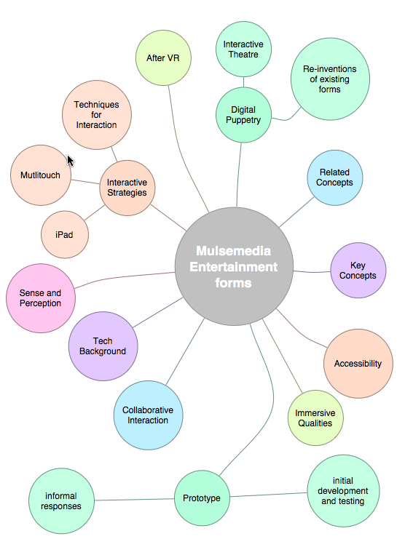

defining object

digital puppetry

expressive play and expressive behaviour
computational affect

entertainment applications

propositions
multi-touch

eye-control

